RTF Proposal

BPMN MIWG Issue # | 98
BPMN MIWG Issue URL | https://github.com/bpmn-miwg/bpmn-miwg-test-suite/issues/98
BPMN MIWG Meeting | 2013-10-16
OMG BPMN Issue # | 17047
OMG BPMN Issue URL | http://www.omg.org/issues/bpmn2-rtf.open.html#Issue17047
Nature | Revision
Severity | Significant
Reported | January 24, 2012
Reported By | Michael Gruenert
Proposal By | Matthias Kurz

Reported Issue
An interesting rule (page 245):
‘A Start Event MUST NOT be a target for Sequence Flows; it MUST NOT have incoming Sequence Flows. An exception to this is when a Start Event is used in an Expanded Sub-Process and is attached to the boundary of that Sub-Process. In this case, a Sequence Flow from the higher-level Process MAY connect to that Start Event in lieu of connecting to the actual boundary of the Sub-Process.’
I never found a tool who implements this rule. On page 261 a ‘Boundary Start event’ does not exist. Only Intermediate Events are of type ‘boundary’ (interrupting/non-interrupting). Or interrupting/non-interrupting Start Events for an Event-Sub-Process (but they are not of type ‘boundary’).
-> is it ok to remove this exception?

Analysis
The spec is inconsistent with regard to boundary start events:
- Figure 7.8 claims boundary start events exist:
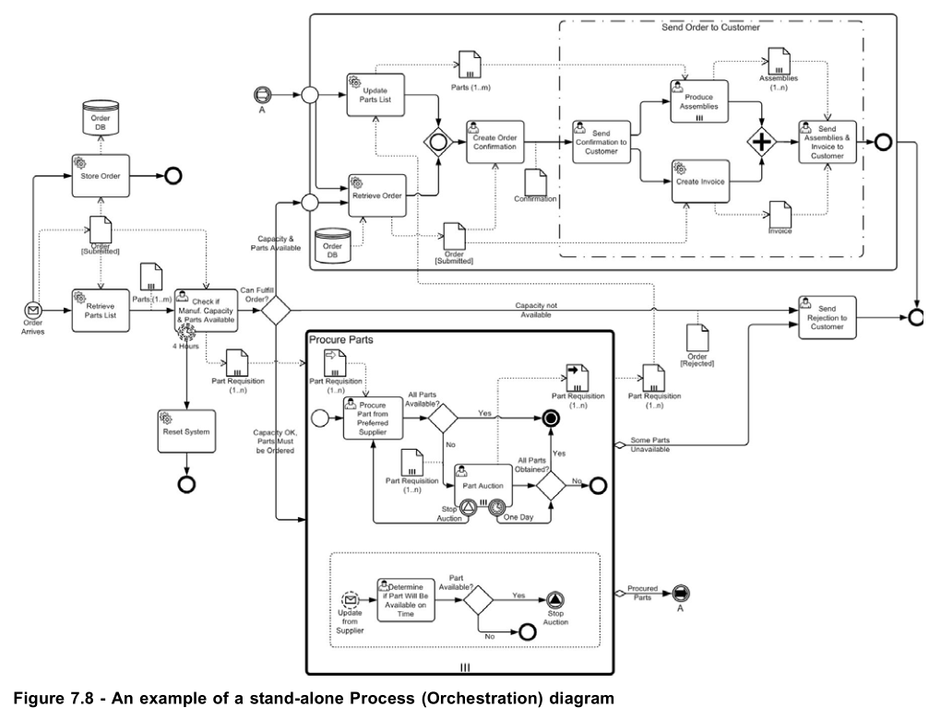
- P 245 claims boundary start events exist:
“An exception to this is when a Start Event is used in an Expanded Sub-Process and is attached to the boundary of that Sub-Process”
- Table 10.93 claims boundary start events do not exist:
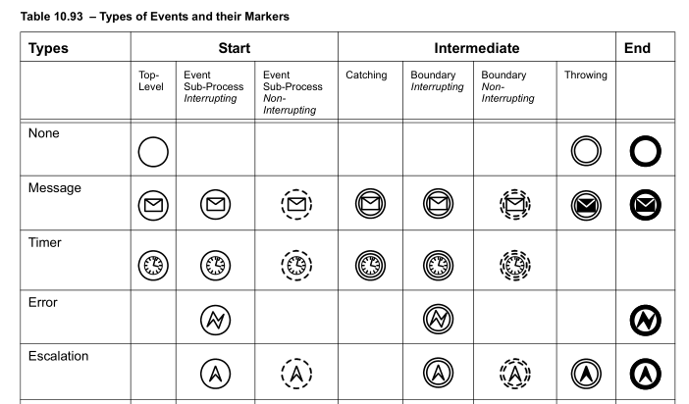

Proposal - Overview
In order to make the spec consistent, we propose to remove boundary start events which are a remnant of BPMN 1.x.

Proposed Changes – Editor Instructions
- Delete the following paragraph from p. 245:
“An exception to this is when a Start Event is used in an Expanded Sub-Process and is attached to the boundary of that Sub-Process. In this case, a Sequence Flow from the higher-level Process MAY connect to that Start Event in lieu of connecting to the actual boundary of the Sub-Process.”
- Remove the boundary start events from Figure 7.8 and replace them like in the following diagram (the changed parts are highlighted red):
